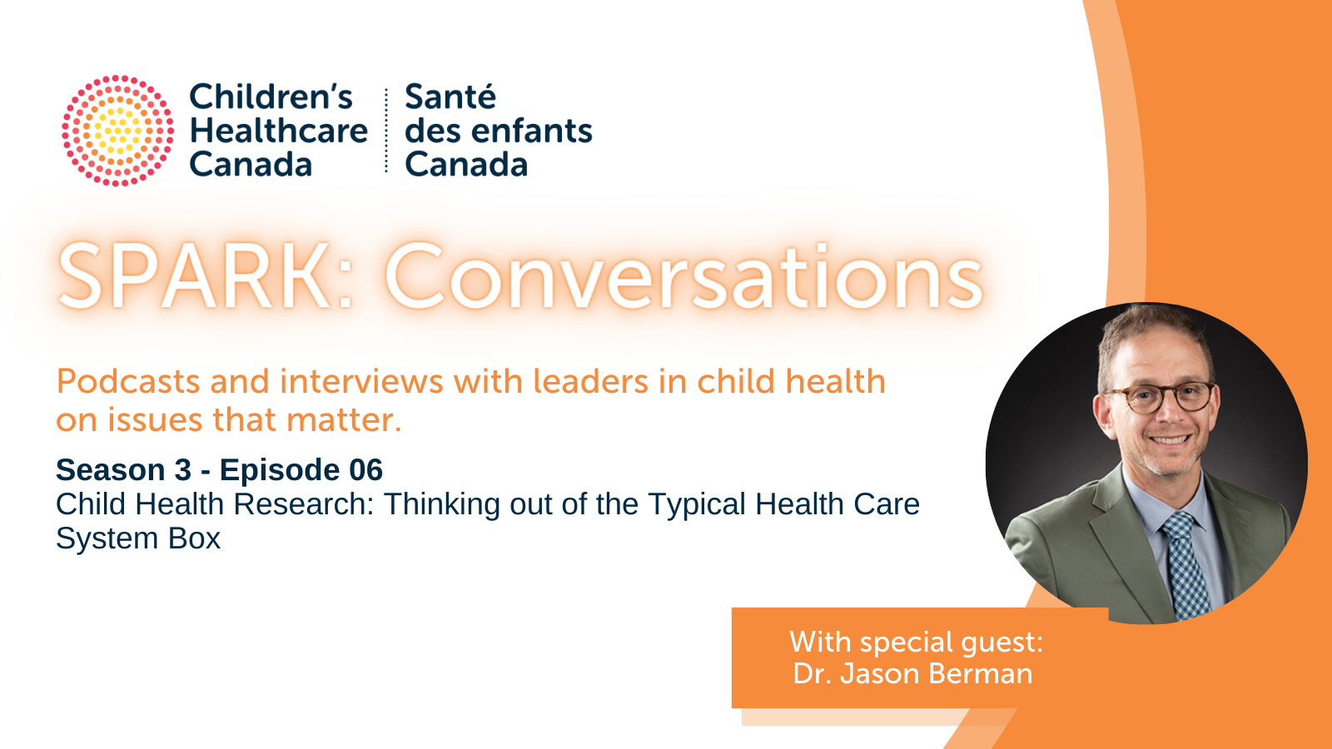

Transcript: Child Health Research
Connected by purpose. Driven by passion. This is Children's Healthcare Canada’s Spark: Conversations podcast series.

Katharine: Welcome to Spark Conversations, Children's Healthcare Canada’s monthly podcast series. At the crossroads of children's healthcare, system improvement, and leadership, SPARK: Conversations is a solution-focused podcast that connects the child and youth health community with system leaders, who tackle wicked problems and discuss ideas to inform the development of innovative and integrated systems serving children and youth. SPARK: Conversations is one component of our SPARK Knowledge Mobilization Program. SPARK is the Shared Platform for Advocacy, Research, and Knowledge.

I'm Dr. Katharine Smart and today I'm delighted to be speaking with Dr. Jason Berman
Dr. Jason Berman is the CEO and Scientific Director of the CHEO Research Institute and the Vice-President Research at CHEO. He is also a Full Professor in the Departments of Pediatrics and Cellular and Molecular Medicine at the University of Ottawa. Previously he served as Associate Chair, Research, Department of Pediatrics, and Professor of Pediatrics, Microbiology & Immunology and Pathology at Dalhousie University and interim Vice President Research, Innovation and Knowledge Translation for the IWK Health Centre in Halifax, Nova Scotia. He is a pediatric hematologist/oncologist and internationally recognized for pioneering research using zebrafish to study childhood cancers and rare inherited diseases.
His laboratory has served as the Atlantic node of the Centre for Drug Research and Development and a national hub for zebrafish modeling of orphan diseases. He has served as president of the Canadian Society for Clinical Investigation, president of the Canadian Hematology Society and is a founding member of the Canadian Rare Disease Models and Mechanisms Network. He is currently Chair of the Board of Directors of the national Maternal Infant Child and Youth Research Network and a member of the board of the Ontario Institute of Cancer Research and the Canadian Institutes of Health Research Institute of Cancer Research.
Today we are chatting about an extremely important topic child health research. Hello, Jason, and Welcome to Spark Conversations.

Jason: Hi Katharine, thanks for having me here.

Katharine: The recent healthcare crisis in pediatrics has really shown us the importance of fostering innovation and research partnerships and working across sectors to bring much needed, innovative change to the healthcare system. Now more than ever we need to form partnerships and find creative solutions to close the gaps in Canadian healthcare systems through catalyzing innovation and bring together healthcare leaders and researchers to address healthcare challenges in new ways and start “thinking outside the box”. Thank you for joining us today to provide some valuable expert advice and I look forward to learning more from you and the work you’ve done.
Jason: Thank you.
Katharine: What do you see as the role of research in helping us address the challenges in our children’s health system facing us currently?
Jason: So, you know health research is really part of the solution to the current healthcare crisis. And it's really vital to protecting and ensuring the long term viability of our healthcare system. And I think generally people tend to think of healthcare in one box and research in another box. And you know, that's not surprising because often they occur in different buildings in different settings. But in many places, like at a CHEO, and many other children's hospitals, most of our researchers are actually clinicians themselves. And much of the healthcare research that happens in Canada happens in hospital based research institutes. And so the fundamental science that occurs in those research institute can drive discoveries that ultimately will save lives and enhance quality of life, clinical research that's undertaken, will benefit those patients located in that center and beyond. And population health services research is really important to understand the needs more broadly, of Canada's population and evaluate how we can organize and operate our health systems in a more effective way.
Katharine: It’s wonderful to see someone like yourself that has a focus on children. Throughout the pandemic we saw so much talk on adults and adult health and those of us who work with children wonder if they are a bit of a forgotten population. Can you tell us why research around the health of children is so important?
Jason: Yes, so this is a great question. And you know, one thing I think that was really highlighted by the pandemic was that children are a bit of a forgotten population. And actually it's not just children in fact, did it we saw this effect earlier in the pandemic on the elderly and people in long term care homes, there tends to be a focus in the health care system both on health care delivery, and often in research on the you know, the general population adults. And we tend to forget about kids who really are our future and, and kids health is really important. We know that in terms of looking at the life trajectory, you know, giving kids a healthy start ensures that they're going to be healthy through adulthood and be less of a burden on the health care system because they're living healthier lives. And so, you know, child health research provides us the opportunity to look in many ways at prevention of diseases, and an early implementation of systems to avoid problems later on. And so thinking of that full health care trajectory, I think is really is really important, and bringing innovative solutions to that.

So again, thinking of those two populations, children and older adults, we've instituted a program together with one of our sister research institutes in Ottawa, the Bruyère Research Institute, to look at this program called eight to 80, where we're looking at how do we bring innovative solutions to help with health care problems at both ends of the of the age spectrum, kids, eight days to adults, 80 years of age, who may seem on the surface to be very different in terms of their needs and challenges. But actually, when you think about things like mobility, hearing, vision, many of those types of things are similar challenges in children and youth. And in fact, one of our surgeons and research entrepreneurs here, Dr. Matt Bromwich developed a hearing testing system called shoebox, he's based at CHEO developed the system here, and now it's being implemented at Bruyère.

Katharine: Wow Jason, I find that so interesting, how you’ve been able to find some parallels between children and older adults and finding synergies between what we are trying to understand about kids in our society and our elders that’s a really interesting perspective.

In a recent op-ed published by the Ottawa Business Journal, you spoke about the importance of research innovation and cross-industry collaborations in tackling today’s healthcare crisis. Can you elaborate on this?

Jason: Yeah, so thank you for referencing that. And you mentioned in your in your opening comments around outside of the box thinking, you know, I think there's very there these silos that exist between clinical folks, research folks, the business community, industrial partners, we need to break down those silos and bring people together. And that's really what we've been trying to do with our innovation core that we've developed here at the CHEO Research Institute.

It's really serving as a missing link in the co-development of products by early stage companies that want to collaborate with late stage researchers. And in some cases, the innovation is coming from the researcher, the clinician themselves and looking at how do we partner with industry to take that to the public. And in other cases, it may be a company that's on the outside of CHEO, that's looking to partner with the clinical and research expertise housed here to have access to a particular patient population and expertise in particular disease processes, so that we can work together to solve problems and it's looking at how do we do that? How do we bring people together to do that. In the past, there was a real sense that if you wanted to do that type of innovative work, if you wanted to start a company, if you wanted to work with a company, you needed to leave academia and so many of those really bright minds that we had in, in hospitals in academic programs, who had these innovative thoughts and innovative plans, felt the need to leave and go to do their industry work outside of the healthcare center we're now trying to bring that in house trying to break down those silos bring people together so we can address those problems in the healthcare center.

Katharine: I love how you’re talking about breaking down silos and thinking outside of the box, I think so often our reluctance to do that has led to the challenges that we have so it’s great to see that you guys have been able through your research and innovation to really bring together those private public partnerships and look at how we can all create a better future of health for children together.

Katharine: The CHEO Research established a new Innovation Core in 2021. Can you speak more about this Innovation Core and the goals of this initiative?

Jason: Yeah, so you know, the, the Innovation Core really is the hub that undertakes this work of bringing together members of the business community, the hospital community, the academic community, creating a structure that really is incubated within the hospital and the research institute to undertake these types of innovation projects, looking at what are the needs of the healthcare system, and how can we bring people together to try to solve those problems? Clinicians, researchers, they're good problem solvers. That’s what we're trained to do. You identify a clinical problem, you identify a research problem, how do you troubleshoot that? How do you come up with this solution? But we're not necessarily trained very well in the business aspects of that. And that's where bringing in those kinds of partnerships can really foster a collaboration that can have meaningful results.

Katharine: I love how you highlight the ability to bring what you’re seeing clinically to the research table and really try to come up with practical solutions that make a difference in the lives of children every day. Tell us a bit about how the world of research is evolving to keep pace with new developments in artificial intelligence, precision health, and data reform?

Jason: Yeah, so there have been a number of opportunities that have come forward in a number of different programs. We have one of our researchers, who is a Canada Research Chair in medical artificial intelligence, Dr. Khalid Al Imam. He's a member of our core, and he's an expert in using synthetic data, to be able to answer key questions and the concept of synthetic data in simple terms, and it's not my expertise, is how do you create a dataset that resembles a real life data set so that you can answer questions, when the real life data set may be hard to access, or you may not be able to get sufficient numbers. And that's often a problem in child health, where we're dealing with rare genetic disorders, or rare conditions that only occur in a small subset of the population.

And to get sufficient numbers of those patients participating, you would have to do studies, national studies, or even international studies. And while those are feasible, potentially there, they take a very long time, and they're very, they can be cost prohibitive. And so the idea of creating a synthetic dataset to try to answer some of those questions, has a lot of value and can then demonstrate, really how to fine tune that study so that ultimately, when you then want to bring in real patients, you know, the exact questions to ask and so, you know, I think that's an example of how artificial intelligence is really being used practically to, to answer those types of questions.

We also, CHEO is the home to a number of provincial registries in Ontario, the Born registry which tracks all every live birth that happens in Ontario, whether it's in a hospital or outside hospital, in so newborn screening that tracks every that that tracks of the blood spots that are done on every on every birth in Ontario, these are very rich databases of information that we can then use to be able to answer really critical questions. And as an example of that, recently, one of our scientists, Dr. Deshayne Fell, identified using the Born database, key safety data around COVID vaccine safety in pregnancy. And so this was really important. Not only did it lead to, you know, a very impactful report, but it also is going to have life changing implications in terms of how clinicians not just across Ontario, but across Canada and around the world approach COVID vaccination in pregnancy. And so that's really the power of having those kinds of datasets to be able to answer key questions.

Katharine: Wow, it’s really fascinating to be able to hear about the work you’re doing and how you’re leveraging things like data to really deeply understand some of the challenges that are facing us right now. So Jason, this Innovation Core sounds really fascinating to me and I’d love to hear a bit more about some examples of what kinds of collaborations and work have come from those partnerships?

Jason: Yeah, so I've mentioned a bit around artificial intelligence, I think that that can be a bit of a scary term. For some people, it seems a little bit foreign. But, you know, if we think about when people talked about smartphone phones and computers a number of years ago, when those first were introduced, I think those were intimidating and overwhelming to many people. And now it's hard to think of anyone getting through their day, no matter what they do, without using a spark smartphone, or a computer interface. And so AI, I really see that as the next step in this in this evolution. It's helping us work together and work better to answer key questions.

I think has a major opportunity to help us with the health, human resources issue where we need, you know, where we were struggling to find enough people to undertake many of these roles, are there AI solutions that can help streamline so that we don't need as many personnel and certain rules so that we can, for example, predict through using AI analytics, the number of patients likely to come to an emergency room or be admitted to a floor so we can better predict nursing, nursing allocations, to those to those shifts, I think those things are going to be very, very helpful. Can AI help a pathologist or a radiologist? better identify diagnoses and so if that can help them streamline that process, yet not replacing that medical expertise, but facilitating and helping that can they get through more cases? So that diagnosis can be made more quickly. And that information can be fed back to the clinician to impact that patient. You spoke about precision health. And you know, precision health, I think is really the future of children's health care.

And this is this idea, precision of having a more tailored approach to treatment, not having a one size fit all fits all. And I really like using that word tailored, because it calls up the analogy of, you know, buying an item of clothing and buying something off the rack that may fit many people or having your clothes tailored so that you have a bespoke item of clothing that's really designed for you. And that's really what we want to have for children's health care. We want to have personalized care that's made to measure and this concept is fairly well established in genetics and rare genetic disorders, which is an area of expertise at CHEO where you identify specific genetic abnormality that's the cause of a given patient's diagnosis, and then try to find a treatment that may be specific, whether it's an enzyme replacement, or gene therapy, or something else that specifically can correct that abnormality.

Similarly, in cancer, we know a lot about the genetics of cancer and trying to match a specific targeted therapy with a particular mutation in a cancer. But this is much more broad in terms of this concept of precision health. And we like to think of it from genetic code to postal code, how do you identify what are the best needs for a specific patient? And so we have a program that CHEO, that serves the mental health population called one call one click that allows individuals either on the phone or through their computer to who have a mental health concern to be able to identify the specific service they need, you know, do they need? Is it an emergency service? Can it wait till tomorrow? Is it a social worker? Is it a psychologist, what's the right sort of provider and service that will meet that individual's needs? And we've grown built on that program into currently a precision Child Mental Health Program that's looking at how do we adapt our mental health system to specifically, you know, meet the needs of individual patients and families. And so it's really this broad idea of made to measure personalized health care for each and every patient and their family.

Katharine: So Jason, I can really tell from your work, the passion you have for research and I’d love for you to share with our listeners, how does research give us hope for the future?

Jason: Well, you know, research, by definition is hope. And, you know, in one of my other roles, I'm a pediatric cancer specialist, I'm a pediatric oncologist. And so I meet with patients and families and often have to talk with them about really difficult diagnoses, and sometimes have to share difficult news with those families. And when we are able to present that there is a clinical trial, that there is a new drug, that there's a new test, that there's a new opportunity that brings families hooked, and time and time again, I've had those families come to me and say, you know, that opportunity, that program, that ability to participate in research, you know, really gave us hope, we know in some cases, it may not make a difference to our child, or maybe didn't make a difference to that child, but recognize that that may contribute to make a difference to a child in the future.

And I really think about that as a clinician researcher, when I'm providing clinical care, I'm thinking about that child and family in front of me and how do I make an impact in terms of improving their health today and in the future, but when I'm engaged in research, I know that can have a broader impact maybe on that child in front of me, but hopefully on many children, not just in my local environment, but beyond that by being able to advance the field and push the needle down further.

Katharine: Jason, thank you so much for sharing your incredible insights with us today, I’ve learned so much listening to you and I’m feeling very inspired. Before we wrap up, I have a few final rapid fire questions. Are you ready?

Jason: Sure.

Katharine: Who has had the biggest influence on your career and why?

Jason: Yeah, so you know, I've had a lot of mentors, research, mentors, clinical mentors. And you know, we talk a lot about in the, in the research world around having different mentors to support your career. But I would have to say it was probably my father who's been gone a long time, but was a clinician and researcher himself, not a pediatrician, he was a cardiologist, but he was someone that always was curious, always asked questions. And so really married research and clinical work, but always was incredibly kind. And so set an example of teamwork and working together and treating everyone as equals to be able to solve problems.

Katharine: What is one thing you feel deeply grateful for right now?
Jason: You know, I feel deeply grateful for I would say it's two things. One is my family because I think you know, we all need family to ground us. And I think many of us have spent a lot of time with our family, maybe more than we expected. During the pandemic, when we were, we were locked down. And so the support of your family I think, is really important. But also, my team here at CHEO, in the Research Institute, in the hospital, my executive, Team colleagues, the members of my lab, the clinicians, I get to work with, we're really a community here. And we all feel like we are rowing in the same direction. And so I think that's really powerful to be part of that team, and being able to advance children's health care.
Katharine: What is the number one thing we need to consider right now to move children’s healthcare forward in a positive direction?

Jason: So, you know, we are in an unprecedented time where we've, you know, identified that we need a right sizing of children's health care that children's health care, really has been undervalued and has not received the attention it needs. So the pandemic, and the recent surge that we've had in many hospitals, including ours has really shone a light on that. And also now and, you know, really timely this week, the discussion happening between the federal government and the premiers around the transfer of additional funds.

And so, you know, a problem has been identified, a solution looks like it's forthcoming with money. But money doesn't solve things. If we don't use it in a smart way we need to really think about it's not just throwing money at the problem and seeing what sticks. It's really working with teams, thinking of how research and innovation can inform better delivery of care. We can't, you know, flip a switch and have all the problems in children's healthcare go away. We have to identify what they are, and then come up working together as teams to try to find solutions and having the opportunity and this unique opportunity of increased transfer payments from the federal government to the provinces to help support that because I think there's going to be competition for those dollars. We want to be able to show that we've come up with really creative solutions to use those dollars in the most effective way.

Katharine: Thank you Jason, it has been a pleasure speaking with you and I’ve learned a ton and I’m sure our listeners will be very inspired.

Jason: Thanks very much, Catherine. Thanks for having me.

Katharine: Stay safe and be well. To stay up to date on all our SPARK offerings, including upcoming podcast episodes, visit our website at ChildrensHealthcareCanada.ca and subscribe to our SPARK: News bi-weekly e-bulletin if you haven't already. Thanks for listening to SPARK: Conversations. And before we go show some love for your new podcast series by leaving us a review and then join us again next month. Thank you.

